

YEAR 12 MATHEMATICS METHODS Test 3 2016
Logarithms

NAME: _________________________________________ Date: Wednesday 29 June 2016

TEACHER: ____________________________

Calculator section: | 15 minutes (max) | 11 marks
Non-Calculator section: |  | 34 marks
OVERALL: | 45 minutes | 45 marks

INSTRUCTIONS:
Show FULL working Answer all questions on this test paper
Questions or parts of questions worth more than two marks require working to be shown to receive full marks.
Allowed: Maths Methods WACE formula sheets, 3 calculators, 1 A4 page of notes

Question 1 [3 + 2 = 5 marks]

a. Accurately plot the graph $y=\log\left(x-3\right)$ on the axes below, clearly detailing the coordinates of any axis intercepts and the equations of any asymptotes.

b. The equation for the function shown below is $y=a×log\left(x+b\right)$
What are the values of a and b ?
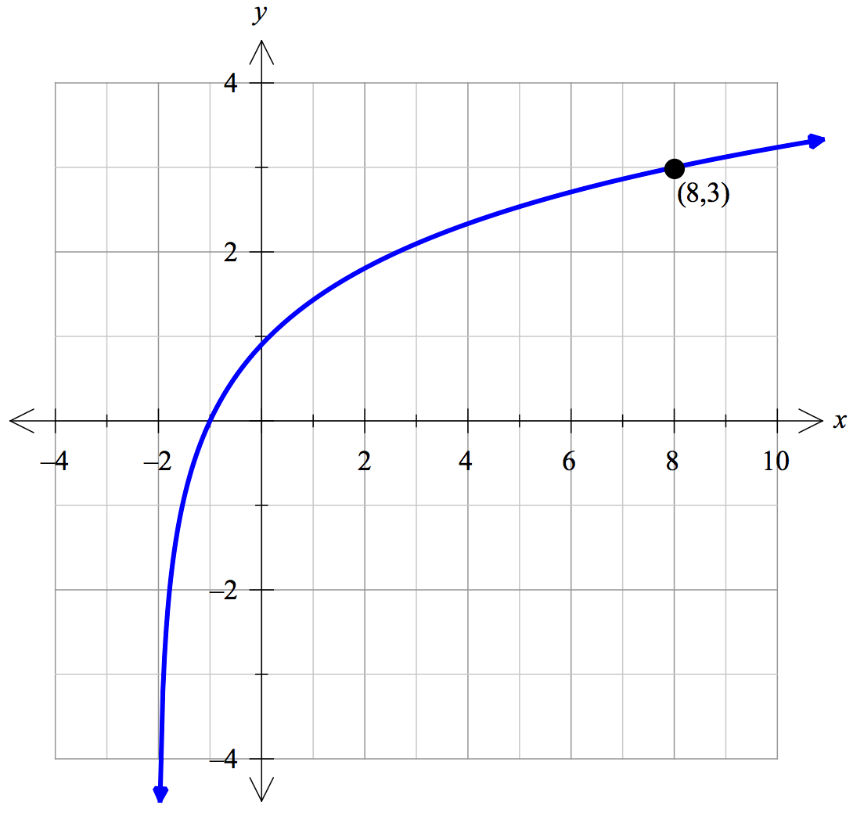

Question 2 [2 + 2 + 2 = 6 marks]

The intensity of sound is measured in decibels. As a consequence of the sensitivity of the human ear, this scale is logarithmic, which allows sound intensities across a wide spectrum (from almost inaudible to ear-splittingly loud). Decibels are measured using the equation below:

$$D=10\log\left(\frac{I}{I_{n}}\right)$$

where D = Decibel level (dB)
I = Intensity of sound in watts per square metre (W/m²)
I_{n} = $1×{10}^{-12}$ W/m² (this is the intensity of the least audible sound a human can hear)

a. Calculate the decibel level for
(i) normal conversation, which has a sound intensity of I = $1×{10}^{-6}$ W/m².

(ii) the kerb-side of a busy road, with a sound intensity of I = $1×{10}^{-4}$ W/m².

b. Calculate the sound intensity (I) that corresponds to the pain threshold of 125 dB.

c. Represent the above three points on the logarithmic graph paper, using them to plot the relationship between I and D
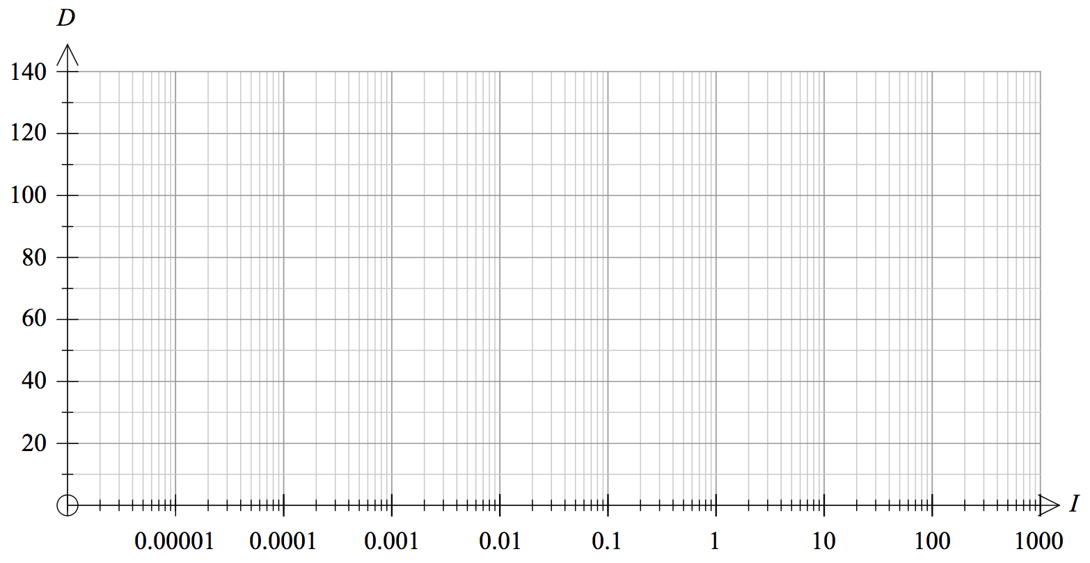

End of calculator section – go back and check your working
Raise your hand when you are ready to go to the non-calculator section
At this stage you may work on both papers (without a calculator or notes)


YEAR 12 MATHEMATICS METHODS Test 3 2016
Logarithms

NAME: _________________________________________ Date: Wednesday 29 June 2016

TEACHER: ____________________________

Calculator section: | 15 minutes (max) | 11 marks
Non-Calculator section: |  | 34 marks
OVERALL: | 45 minutes | 45 marks

INSTRUCTIONS:
Show FULL working Answer all questions on this test paper
Questions or parts of questions worth more than two marks require working to be shown to receive full marks.
Allowed: Maths Methods WACE formula sheets, 1 A4 page of notes

Question 3 [2 marks]
a. Write $\log_{2}{64}=6$ as an exponential statement:

b. Write $3^{x}=7$ as a logarithmic statement:

Question 4 [1 + 1 + 2 + 1 = 5 marks]
Evaluate the following:
a. $\log_{2}{32}$ b. $\log_{3}{\frac{1}{9}}$

c. $5+3 ln{e^{2}}$ d. $3^{\log_{3}{5}}$

Question 5 [2 + 2 = 4 marks]
Express each of the following as a single logarithm:
a. $4\log{a}-2\log{b}+\log{c^{3}}$

b. $\log_{7}{xy}-2+\log_{7}{10}$

Question 6 [2 + 3 + 4 = 9 marks]
Solve using your knowledge of logarithms, giving solutions as exact values in simplest form.

a. $2\left(5^{x}\right)=12$

b. $3^{x+1}=4^{2x}$

c. $e^{2x}-5\left(e^{x}\right)=14$

Question 7 [3 + 4 = 7 marks]
a. Calculate $\frac{d}{dx}$ for the following:

(i) $\ln\left(3-4x\right)$ (ii) $\ln\left(\sqrt{2x^{3}+1}\right)$

b. Evaluate the following integrals:

(i) $\int{\frac{12x^{2}}{7-x^{3}}dx}$ (ii) $\int{2\tan\left(4x+1\right)dx}$

Question 8 [4 + 3 = 7 marks]

a. Calculate the equation of the tangent to the curve $y=\ln{x}$ at the point $\left(e^{2},2\right)$.

b. Evaluate the area contained between the function $y=\frac{4}{x}$ and the x-axis from an x-value of e to an x-value of e³.

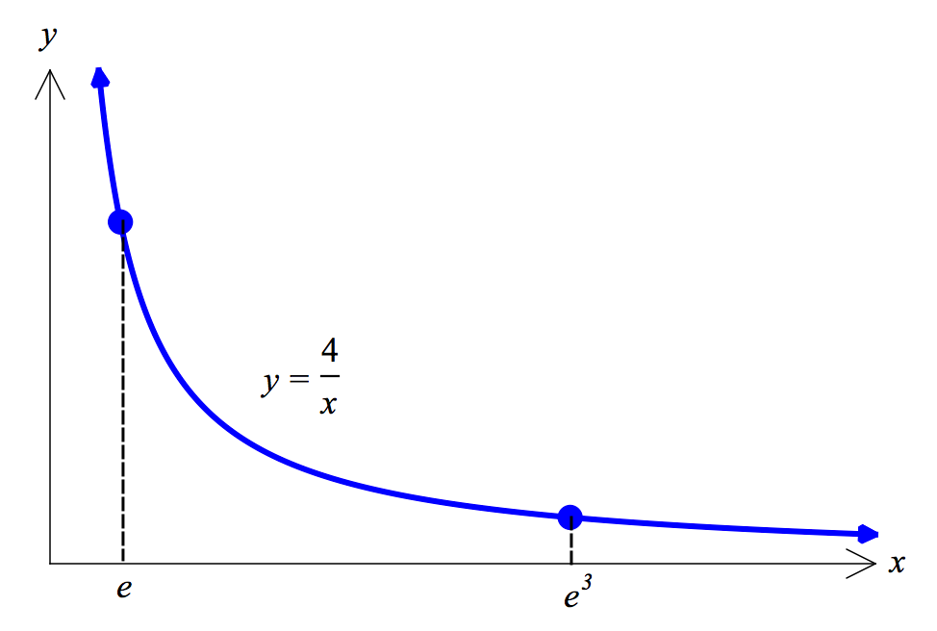

End of non-calculator section – go back and check your working

